**Directors/Directing**

Although some official has organized the acting and scenery in theatrical performances since ancient Greece, the director only emerged as a significant creative figure in the late nineteenth century. Directors introduced innovative acting methods, modernized staging through new technologies such as electric light and mechanized scenery, proposed theories about the function of the theatre in social and political life, and provided unified interpretations of complex plays. As the self-designated authors of productions, directors often competed with playwrights and actors for artistic control, a tension that continues to characterize the division of labor in theatres.

The first modern director is thought to be Georg II, Duke of Saxe-Meiningen, who established a court theatre in 1866 that toured widely in Europe. Georg II trained as a painter and he designed the costumes and setting for his early productions so that every person and object on stage would harmonize in one complete scenic composition. He also choreographed crowd scenes in which every actor was given individualized movements that complemented the main action of a scene. To reinforce the subordination of every part to a representational whole, Georg II insisted that his actors work as an ensemble in which stars could be asked to play minor roles to serve the needs of a play. When the Meininger production of *Julius Caesar* premiered in Berlin in 1874, reviewers praised the company’s discipline even though they slighted individual performances.

While the Meininger specialized in German classics and Shakespeare, André Antoine in France and Otto Brahm in Germany promoted new naturalist drama by playwrights such as Leo Tolstoy, Henrik Ibsen, and Gerhart Hauptmann. Since naturalist plays investigated how heredity and the social environment determine individual agency, naturalist directors devised stage settings that carefully reproduced contemporary working and living conditions. At the Théâtre Libre, Antoine received widespread praise for a production of Tolstoy’s *The Power of Darkness* in 1887 that included costumes and props obtained from the Russian émigré community in Paris. Other techniques, such as hiring untrained actors and encouraging his performers to play, at times, with their backs to the audience, enabled Antoine to foster the illusion that his stage was enclosed by an imaginary ‘fourth wall’ through which audiences could glimpse a scene from real life.

In Russia, Konstantin Stanislavsky similarly worked to reproduce a sense of real life on stage. He opened the Moscow Art Theatre in 1898 by directing Count Alexei Tolstoy’s historical drama *Tsar Fyodor Ivanovich*, basing his production on the model of the Meininger, which he had seen during its 1890 tour, with costumes and props derived from drawings of sixteenth-century court life. Stanislavsky modified his understanding of naturalism when he staged Anton Chekhov’s *The Seagull*, also in 1898. After studying Chekhov’s play about rivalries in love and art on a country estate, Stanislavsky discovered what he called a “sub-text,” a pattern of unspoken desires beneath the characters’ apparently disconnected actions that he evoked by dictating every gesture and sound effect. Stanislavsky’s score of movements and noises was, in effect, a second play inspired by Chekhov’s script, a plan for using sensuous details to create a charged emotional atmosphere.

As Stanislavsky worked to refine the representation of reality on stage, other directors pronounced and heightened its artifice. Max Reinhardt built a theatrical empire in Germany and Austria by staging fantastic spectacles on a grand scale, such as his 1905 production of *A Midsummer Night’s Dream* at the Kleines Theater in Berlin, which featured a revolving stage, a papier-mâché forest, and artfully simulated moonlight. Vsevolod Meyerhold, who began his career as an actor at the Moscow Art Theatre, brought the conscious theatricality of the circus, religious pageants, and puppet shows to his stylized productions. In his 1906 staging of Alexander Blok’s *The Fairground Booth*, a play that juxtaposes commedia dell’arte clowns and sober mystics, Meyerhold instructed his actors to emphasize the sudden, grotesque shifts between comedy and tragedy in their roles, to accentuate their virtuosity as performers rather than their consistency as characters.

Erwin Piscator and Bertolt Brecht, two directors who worked as dramaturgs at Reinhardt’s theatres, deployed theatrical artifice and the asymmetry between actors and their roles to question their audience’s political convictions. Piscator’s technologically sophisticated productions framed individual actions within broader historical contexts. In his 1924 production of *Flags* at the Volksbühne in Berlin, he flanked a documentary play about union leaders persecuted by corrupt police with slides showing newspapers, posters, and explanatory title cards. Brecht likewise used distancing devices, including the signs at the premiere of his 1921 play *Drums in the Nights* that admonished audiences “Don’t stare so romantically!” and applying white chalk to the faces of actors playing soldiers in his 1924 production of Christopher Marlowe’s *Edward II* to highlight their fear and exhaustion.

Directors spread their ideas in writing as well as through their work on stage. Swiss architect Adolphe Appia and English actor, designer, and director Edward Gordon Craig, for example, influenced modern directors primarily through their designs and treatises rather than their few productions. In *Music and Stage Setting* (1899), Appia proposed that Richard Wagner’s operas could best be visualized with abstract compositions of light, actors, and minimalist scenery that responded to the dynamic flow of the music. Craig, in ‘The Actor and the Über-Marionette’ (1908), determined that the actor’s body was not suitable material for theatrical creation because even the actor himself could never fully bring it under control. Instead, Craig suggested that directors replace actors with anthropomorphic puppets, or at least encourage actors to imitate the impersonality of objects. While few applied their principles literally, Appia and Craig provoked directors to experiment with the elements—bodies, words, music, space, and light—of theatrical composition.

Reinhardt likewise made a *Regiebuch* (director’s book) for each production, a combination of sketches, notations, and short descriptions that meticulously documented his intentions and was used by his assistants to conduct rehearsals in his absence. Brecht adapted Reinhardt’s template in his *Modellbücher* (pattern books), experimental collations of photographs, dialogues, and explanations of scripts that he published in the 1940s and 1950s to disseminate his theatrical theories. This directorial writing preserves, in partial form, the labor and thought of directors in the act of defining their roles as interpreters, autocrats, teachers, and coordinators of stage technology in the modern era.

**References and Further Reading:**

Braun, Edward. (1982) *The Director and the Stage: From Naturalism to Grotowski*, London: Methuen Drama.

Cole, Toby and Helen Krich Chinoy, eds. (1963) *Directors on Directing: A Source Book of the Modern Theatre*, Indianapolis: Bobbs-Merrill.

Innes, Christopher and Maria Shevtsova. (2013) *The Cambridge Introduction to Theatre Directing*, Cambridge: Cambridge University Press.

Jones, David Richard. (1987) *Great Directors at Work: Stanislavsky, Brecht, Kazan, Brook*, Berkeley: University of California Press.

Shepherd, Simon. (2012) *Direction: Readings in Theatre Practice*, Houndmills, UK: Palgrave Macmillan.

**Lawrence Switzky, University of Toronto**

**Recommended Illustrations:**

[Please use all seven proposed illustrations if possible to give a sense of each director’s distinct aesthetic.]

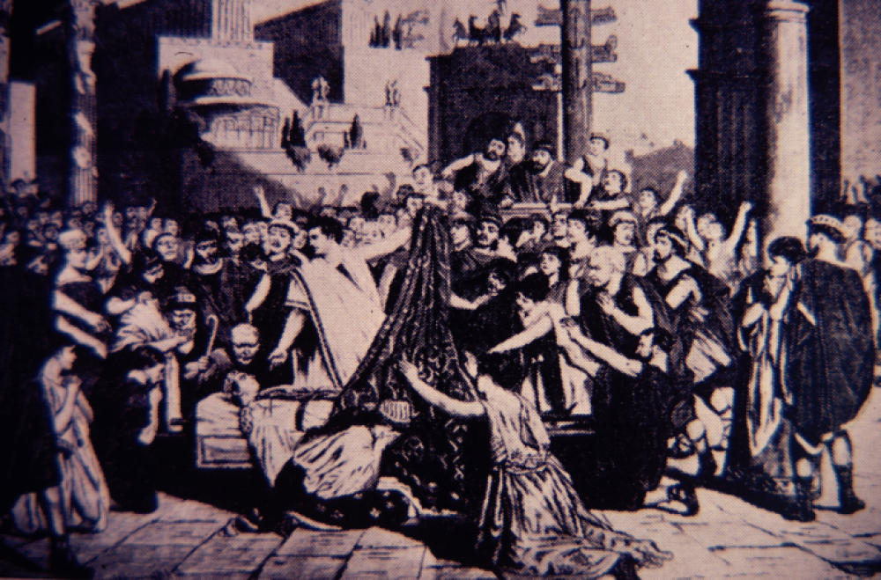

**Marc Antony’s funeral oration in *Julius Caesar*; illustration by Julius Kleinmichel, based on a sketch by Georg II, Duke of Saxe-Meiningen (1874).**

[Available at: http://library.calvin.edu/hda/node/1993]

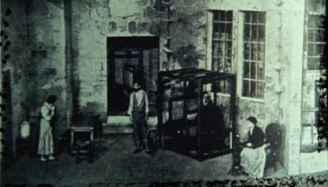

**André Antoine’s naturalist production of Gerhart Hauptmann’s *The Weavers* at the Théâtre Libre in Paris (ca. 1890s).**

[Available at: <http://library.calvin.edu/hda/sites/default/files/imagecache/medium/cas788h.jpg> ]

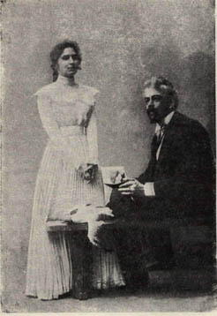

**Maria Roksanova (Nina) and Konstantin Stanislavsky (Trigorin) in a posed shot from Stanislavsky’s production of *The Seagull* (1898).**

[Available at: <http://en.wikipedia.org/wiki/File:Stanislavski_Seagull.jpg> ]

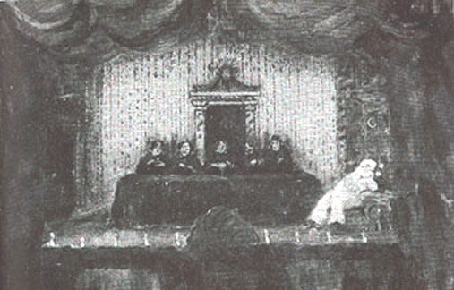

**Sketch of the opening scene of Vsevolod Meyerhold’s production of *The Fairground Booth*, with the mystics at the center and Pierrot at the right (1906).**

[Available at: <http://max.mmlc.northwestern.edu/~mdenner/Drama/plays/playimages/sapunov-40.jpg> ]

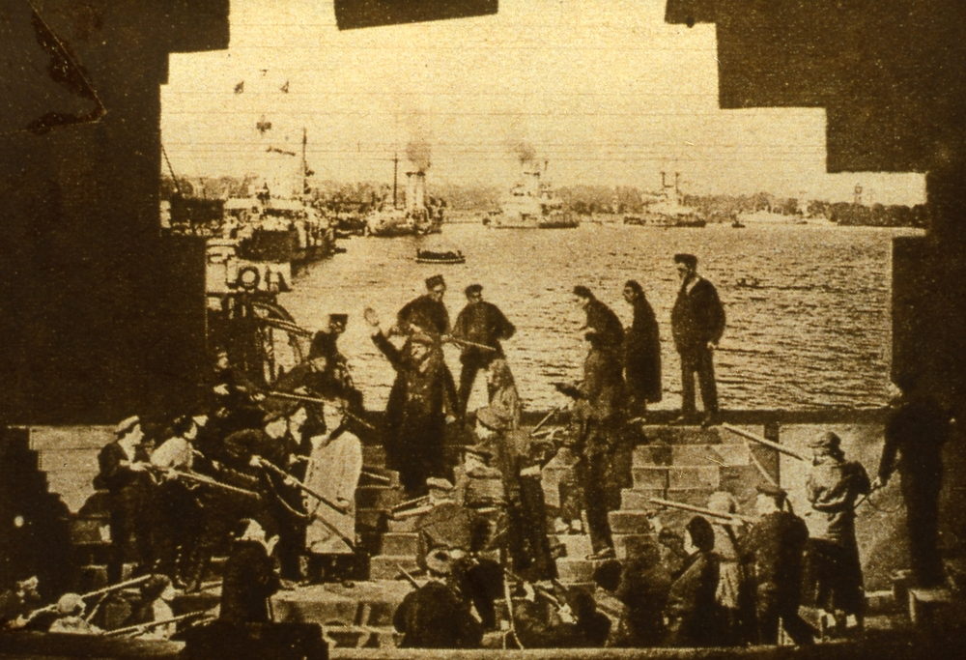

**Erwin Piscator’s production of *Flags* (1926).**

[Available at: <http://dokumenttiteatteri.files.wordpress.com/2011/02/piscator013_dia_06_fahnen-scaled1000.jpg> ]

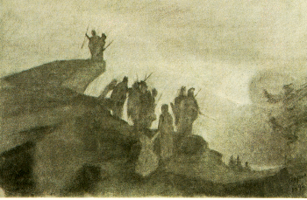

**Adolphe Appia’s design for Act II of Richard Wagner’s *Die Walküre* (1892).**

[Available at: <http://dvtg.hku.nl/licht/appia-~2.htm> ]

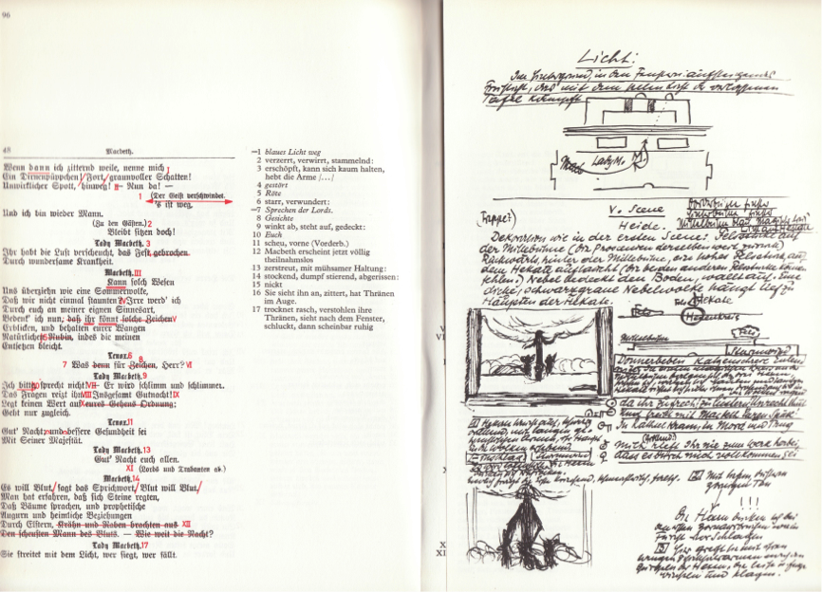

**A Page from Max Reinhardt’s *Regiebuch* (director’s book) for *Macbeth* (1916).**

**[Available at:** <http://www.visualpoetics.be/media/upload/1367936598.png> ]